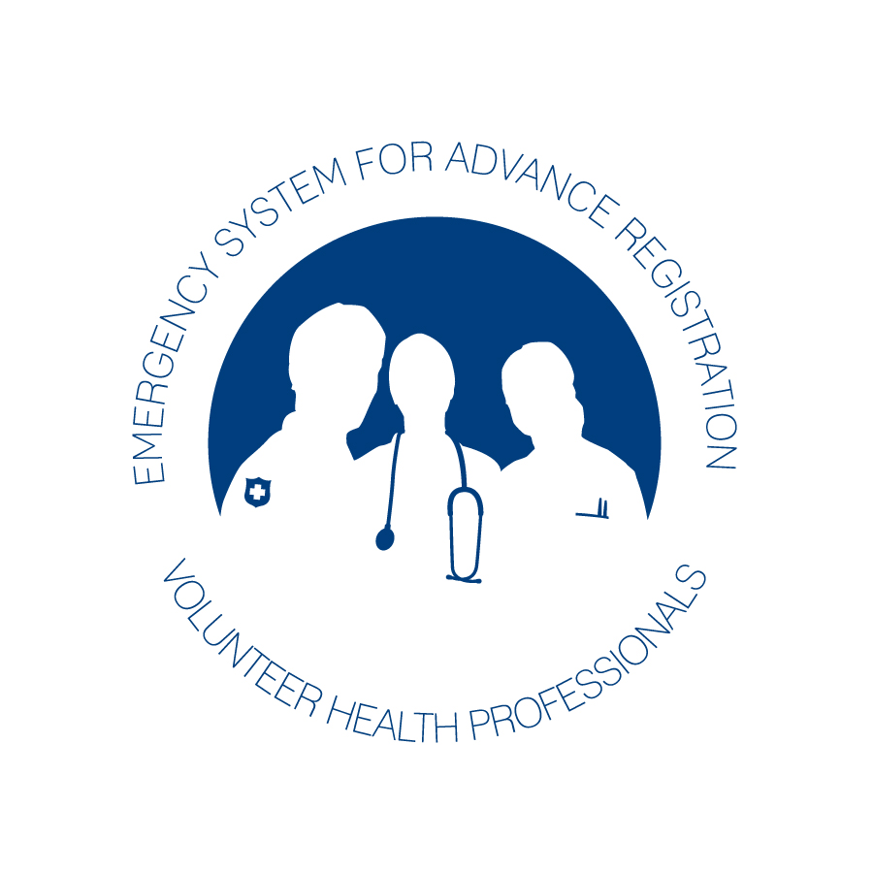
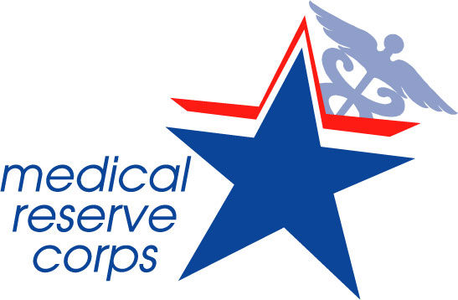
Medical Reserve Corps (MRC)
Volunteer Agreement for
Hawaii and the Pacific
Island Jurisdictions

VOLUNTEER CERTIFICATION:
I hereby certify that all the information which I have provided during the Medical Reserve Corps application process is accurate and correct and I hereby make application for membership in the Medical Reserve Corps affiliated with the appropriate unit/organization. I understand that I am applying for a volunteer position and that this is not an application for, or contract of, employment. If any of the information given on this application is incomplete or untrue, I understand that my assignment may be terminated.

VOLUNTEER CONSENT FOR REFERENCE, CREDENTIAL, AND BACKGROUND CHECKS:
I hereby give the Medical Reserve Corps and/or the Department of Health (as appropriately affiliated with the specific unit/organization), permission to inquire into my licenses, credentials, educational background, references, driving record, police records, employment and my volunteer history. Information needed to conduct background checks include, but are not limited to, social security number, legal name, and birth date. I further give permission to the holder of any such records to release this information to the Medical Reserve Corps/Department of Health or its sponsoring agencies. I understand that the Medical Reserve Corps/Department of Health will only use this information as part of its verification of my volunteer application and periodically for evaluation purposes. I do hereby hold the Medical Reserve Corps/Department of Health harmless from any liability, whether civil or criminal, which may arise as a result of the release of this information. I further hold harmless any individual, agency, business or corporation that provides information or documents to the Medical Reserve Corps/Department of Health. I further understand that there may be additional screening procedures and that I will be required to sign the Code of Conduct.

VOLUNTEER CONSENT FOR RELEASE OF INFORMATION:
I do hereby give the Medical Reserve Corps/Department of Health permission to release personal information to local, state, and federal emergency management agencies and other Health and Human Services agencies as needed. In addition, I give my consent to use my image and name as a MRC volunteer in publicity about the program, as needed. There is no expiration on this permission unless notified.

STATEMENT OF UNDERSTANDING AND CONFIDENTIALITY:
I understand that as a volunteer with Medical Reserve Corps/Department of Health (as appropriately affiliated with the specific unit/organization), that all information that I hear and see is strictly confidential and is not to be discussed outside of the Medical Reserve Corps/Department of Health. I agree to observe the policies and procedures of the Medical Reserve Corps/Department of Health.

The Medical Reserve Corps/ Department of Health does not discriminate on the basis of race, color, religion, sex, national origin, age, ancestry, marital status, unfavorable discharge from the military, disability or any other legally protected status, in accordance with applicable legal requirements.
This is an Affirmative Action/Equal Opportunity Organization.

A Photocopy of this release form will be valid as an original thereof even though the said photocopy does not contain an original writing of my signature.

